Framework for stakeholder involvement in eHealth Action Research

This framework is an extension of other descriptions of Action Research, building on the core cyclical process of planning, action and reflection. It also includes the collaborative conception of a project idea, as well as steps to ensure sustainability of the change in practice after a project has ended. Additionally, activities are included within and between the steps of the action research cycles.
It should be noted that this is a very straight-forward and structured representation of a project process. In practice, cycles will be less distinguished and there might not be a clear endpoint to a project. Of course, the context of a research project and the involved stakeholders, play a large role in shaping the actual process of the project.
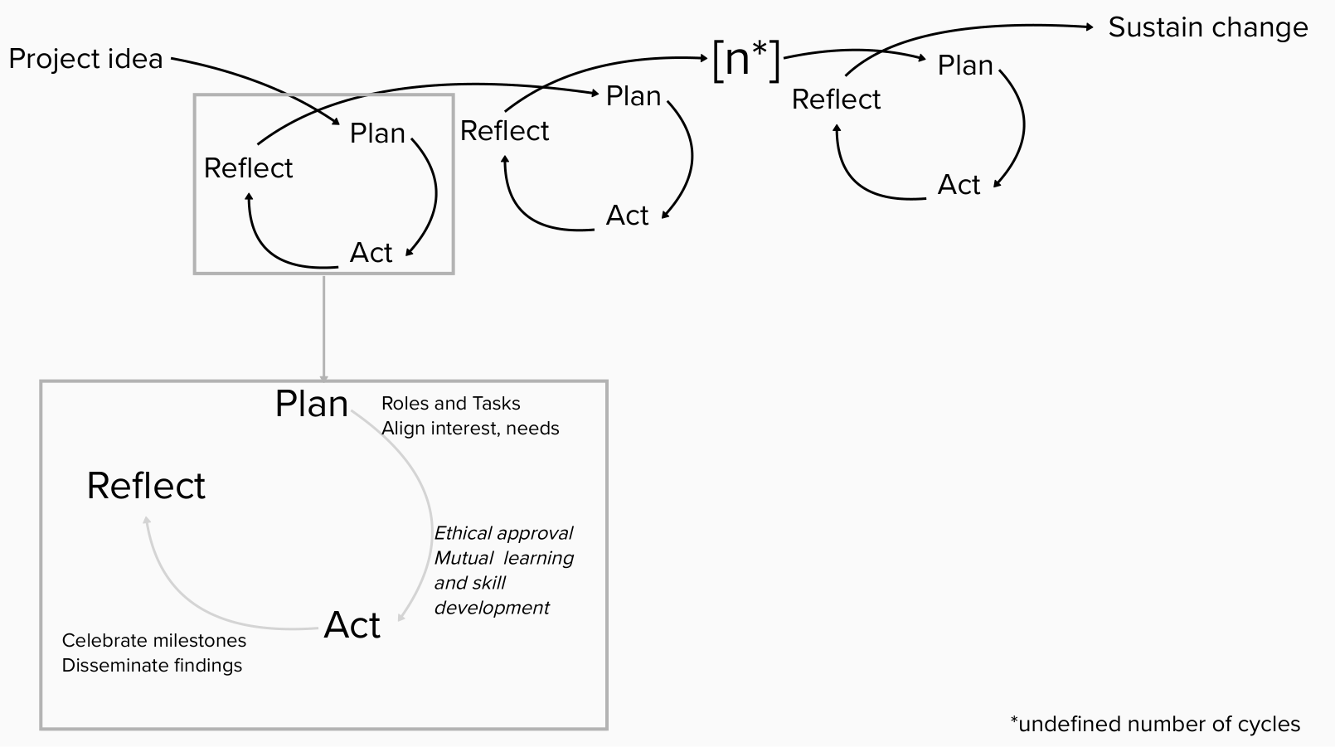
You can find more information about each of the actions below. After a brief explanation, pointer questions are provided, which you can answer in order to shape your research. This can be done by a researcher themselves, or together with the other involved stakeholders in the research team.

Project Idea
Ideally, the idea for a project should come from stakeholders or the community. At the least it should be shaped and co-written together with them. Still, not all stakeholders might be in favour of a project, and it will take time to settle on a project idea and build a project team.
- Did we identify all relevant stakeholders that need to be involved in this project?
- Were (representative of) all relevant stakeholders actively involved in setting up the project idea?
- Were the intended “users” able to give their input?
- Are stakeholders re-imbursed for their involvement in developing the idea? (note: while reimbursement can be financial, this can also mean e.g. having allocated (working) hours for a project, or receiving recognition)
- Are there ways to receive funding to further develop the idea?
- Have we planned and budgeted for project supervision / exchange with other project?

Plan
Every cycle of AR starts with a more or less defined planning phase. In this phase the next steps are set out, in many cases based on previous findings or reflections. Below, two important elements of planning a new cycles are outlined: dividing roles and tasks and aligning the interests and needs of all involved parties.
Roles and tasks
The role of the researchers is different in a project with involved stakeholders. They need to share power and hand over responsibility. Similarly, stakeholder take on more active and empowered roles. It is important to make these roles explicit and to discuss how tasks are divided, yet the roles might be less clear and distinct in practice. It is important to have leave room for such negotiations and document the decisions that are made clearly and accessibly.
- Who are the stakeholders involved in our project team? Who needs to be involved as participants? How will other stakeholders be involved and connected to the project?
- Who will take on which roles and tasks?
- Who are (potential) champions in our project? How can we involve them?
- What can we do to keep all groups involved?
- How are we setting up communication between partners? Do these (digital) tools work for everyone?
- What are risk we foresee and how can we mitigate those risks? How will we deal with e.g. changes in leadership / politics?
- How will we evaluate the outcomes of our project?
At later stages ask:
- Is everybody still happy with their role? (ask individually)
- Are there new tasks that need to be divided?
- Are there new stakeholders that need to be involved? How?

Align interests, needs
Different stakeholder groups will bring their own ideas and needs into a project, which may sometimes conflict. This conflict is a normal part of the process, but one that should be acknowledged. Therefore, being open and trying to mitigate between stakeholders is crucial to do throughout the project. This openness requires a lot of courage from all involved parties. Still, it might be impossible to align interests, but a collaboration between the involved parties should still be made possible.
- How can we map everybody’s goals for, and interests in, the project?
- What are our common values?
- Where do these needs conflict and how can we deal with that?
- How is the target group involved in setting our plans? Is there a good fit between the plans and the target group?
At a later stages ask:
- Are the needs still the same?
- Do we need to re-align?

Ethical approval
As the roles of stakeholder groups change, it can be difficult to explain the involvement of certain groups to ethical boards (e.g., patients are seen as vulnerable groups). Additionally, receiving ethical approval for iterative research can be more difficult as the research process changes continuously.
- Have we talked to our ethical committee and are we aware of procedures for this type of research (e.g., amendments)?
- Do we need ethical approval for this part of the research?
- Have we considered important ethical issues (e.g. compensation, burden)?
- Are we aware of all ethical guidelines that apply (e.g., GDPR)?
- Was the extent of the research clearly explained to participants?
- How are we dealing with stakeholders / participants who do not give consent?

Mutual learning and skill development
Both researchers and involved stakeholders might need additional skills to take on this new role in the research process. These can be general research skills, but will oftentimes be context dependent.
- Which skills are needed, and by whom?
- Who can provide the training? What do they need to do so? (‘training the trainer’)
- What will the training look like?
- How can we make the training accessible? How can we adjust the training to different stakeholders / stakeholder groups?
- Are there hierarchies and power dynamics we need to take into account (e.g. doctor-patient relationship)? How are we going to deal with those?

Act
In the action phase, the steps that were planned for are carried out. What this means will be highly different per project and per cycle, but below two important elements of the act phase are described: celebrating milestones while learning from failures, and disseminating of the project and its findings.
Celebrate milestones and learn from failures
A project may not achieve all it set out to do. Additionally, in the process, successes might get lost. Therefore, explicitly setting celebratory moments together with the whole team can help keep up motivation and show achievements. These do not have to be big, formal events, but can also be a small acknowledgement during a meeting. Milestones can take a variety of forms, not only related to project outcomes, but also to the experiences during the project. At the same time, failure to achieve a success provides a learning opportunity for the future, which should be made use of.
- How do we define success?
- What are our successes?
- How will we celebrate them?
- Who will be part of the celebration?
- How can we present the achievement?
- What can we learn from the things that did not go well?

Dissemination
As the project is set in practice and aims to make an impact, it is important that stakeholders outside of the research team, who are not involved in the project in any way, are aware of the project and its progress. There are many different forms of dissemination that will be useful to different degrees in a project. The information provided can also be different, e.g. about outcomes of the project versus describing the research process and lessons learned about that.
- What is the goal of our dissemination? Why is it relevant to disseminate this?
- Who do we want to reach with our dissemination?
- How can we reach them? What are suitable ways of dissemination?
- Which information should we provide?
- How can we best provide this information?

Reflect
Reflection is a central element of AR. By reflecting on the process, problems can be seen and fixed earlier. It is important to involve all relevant stakeholders in this process to not exclude their perspective. Reflection can take place on different levels, reflecting on the outcomes of the project, the way of working together, or the individual role, for example of the main researcher. Reflection happens continuously throughout the project, at intervals set by the project team.
- How are we going to structure our reflection? Which tools can we use for reflection?
- Did we achieved what we planned to do?
- What went well, and what did not?
- How will we address this in the future?
- Which mitigation plan(s) and ways of dealing with risks and challenges do we need?
- How can we plan for future sustainability of the change we are making?
At later stages also ask:
- Did our changes from previous reflections happen and work out?

Sustain change
The project should be beneficial for practice, even after funding has ended. Therefore, the team should make plans for sustaining the changes long before the project is set to end, so as to be able to make arrangements. So, while this is the last step in this framework, it should receive attention throughout the whole process. There is a balance between remaining flexible as project team and having a lasting impact through connections with for example policy makers. Each projects needs to weigh these options and find an individual solution to sustain the project.
- What needs to happen to sustain the change?
- Is there funding available?
- Is it possible to implement the change in policy / regulations?
- Who needs to be involved?
- Who can facilitate the change?

Additional reading
To support you in your research project, we have compiled a list of recommended reading for the different elements of this framework. We try to update this list based on our own work, and input from users of the framework.
Find an example of starting a project together with stakeholders:
Hand, C., Rudman, D. L., McGrath, C., Donnelly, C., & Sands, M. (2019). Initiating participatory action research with older adults: Lessons learned through reflexivity. Canadian Journal on Aging/La Revue canadienne du vieillissement, 38(4), 512-520.
Read more about stakeholder analysis:
Franco-Trigo, L., Fernandez-Llimos, F., Martínez-Martínez, F., Benrimoj, S. I., & Sabater-Hernández, D. (2020). Stakeholder analysis in health innovation planning processes: a systematic scoping review. Health Policy, 124(10), 1083-1099.
Read more about Champions:
Miech, E. J., Rattray, N. A., Flanagan, M. E., Damschroder, L., Schmid, A. A., & Damush, T. M. (2018). Inside help: an integrative review of champions in healthcare-related implementation. SAGE open medicine, 6, 2050312118773261.
Find an example of role definition (via the participation matrix):
de Wit, M., Beurskens, A., Piškur, B., Stoffers, E., & Moser, A. (2018). Preparing researchers for patient and public involvement in scientific research: development of a hands‐on learning approach through action research. Health Expectations, 21(4), 752-763.
Read more about ethical issues in participatory research, including recommendations for dealing with these issues:
Kwan, C., & Walsh, C. A. (2018). Ethical Issues in Conducting Community-Based Participatory Research: A Narrative Review of the Literature. Qualitative report, 23(2).
Read more about how to disseminate AR findings:
Smith, L., Rosenzweig, L., & Schmidt, M. (2010). Best practices in the reporting of participatory action research: embracing both the forest and the trees 1Ψ7. The Counseling Psychologist, 38(8), 1115-1138.
Find recommendations for sustaining a project:
Meurer, J., Müller, C., Simone, C., Wagner, I., & Wulf, V. (2018). Designing for sustainability: Key issues of ICT projects for ageing at home. Computer Supported Cooperative Work (CSCW), 27, 495-537.

Disclaimer
This framework was developed for the context of eHealth action research. Projects can differ greatly, making it challenging to find a balance between specific information and general advice that is applicable on a broader level.

Champions are stakeholders that drive a project and get beyond what is expected of them in their role. For more information, see the Additional Reading section.

